Add new Python Graph

# Introduction

The purpose of this document is to instruct how to create a graph using Python with the data source of the udw (impala). We will create a dig metric graph as example.

# Dig Metrics

Plot all of the beginning dig locations for a shift using this:

Use dig_start_ang and dig_start_tooth_extension

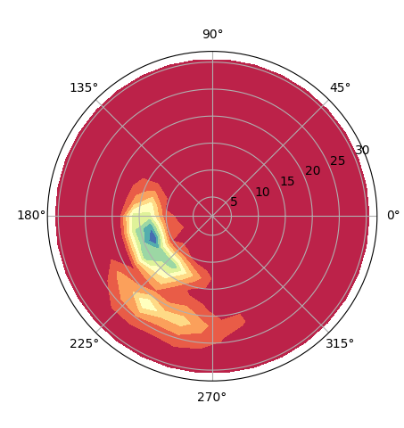

# Django REST Framework

We use Django REST framework to create our python restful API. For the tutorial of the Django rest framework please refer to the below link.

Link: <http://www.django-rest-framework.org/>

# pYTHON GRAPH

We use matplotlib to create our python graph. For the tutorial of the matplotlib, refer to the below links.

Links:

<https://stackoverflow.com/questions/40327794/contour-density-plot-in-matplotlib-using-polar-coordinates>

https://matplotlib.org/

# Our dJango restful api

1. Code Structure

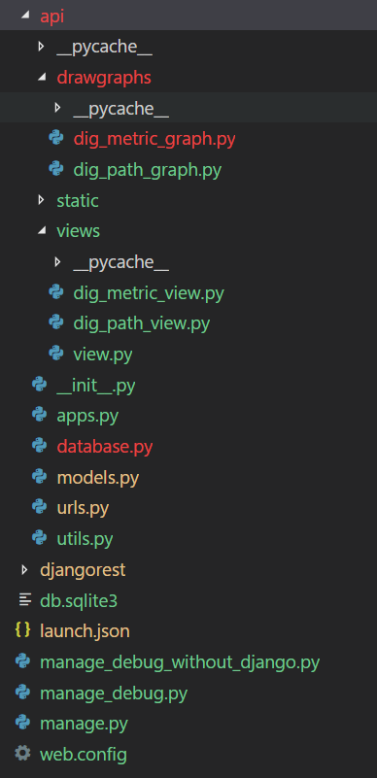

manage_debug.py is used to debug with Django.

manage_debug_without_django.py is used to debug without Django.

1. Steps of adding a new graph.
2. Add a new dig_metric_view.py in /api/views folder.
3. Add a new dig_metric_graph.py in /api/drawgraphs folder.
4. Add a new function get_dig_metric_data in /api/models.py.
5. Add the URL route in /api/urls.py
6. Run the server with command [python manage.py runserver].

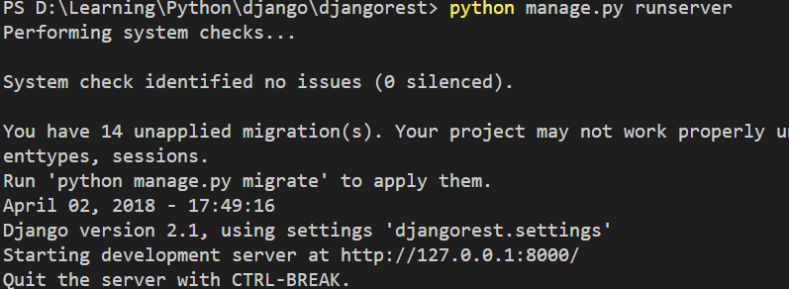

1. Call the API in chrome with URL:

<http://127.0.0.1:8000/get_dig_metric_graph?shift_start_timestamp=1517853600000&locale=fr>

<http://127.0.0.1:8000/get_dig_path_graph?equipment=ES41276&locale=fr>

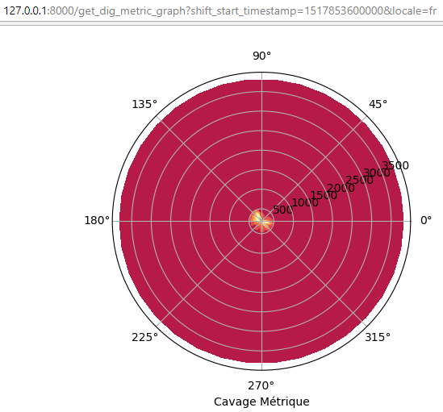

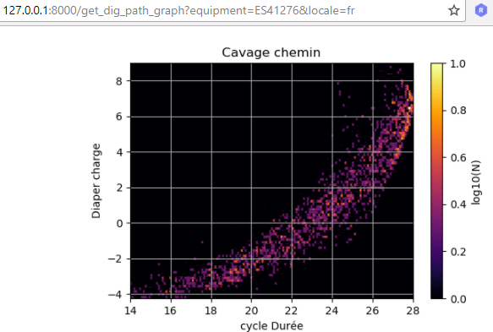

# Code path

\AnalyticsDevelopment\src\Python\scripts\main\common\SSRS Image Server